FLORIDA WINTER ADVENTURE ROWING TOUR

Registration Form

Name: ________________________________________
Street or P.O. Address _____________________________ City _________________
Prov./State ______________ Postal/ZIP Code ____________
Phone numbers: Home: (______) ____________Work: (______) ____________
Cell: (______) ________________
E-mail address: ______________________ (Communication is generally by e-mail)
Emergency contact:
Name: ---------------------------------------------------------------------------------
Phone Number: ------------------------------
Club/Association affiliation: ________________________ OAR membership: Yes or No
For how many years have you sculled? ______

 | $ US | $CDN | Your fee (please indicate the denomination)
Deposit for tour¹ | 300 | 380
OAR membership (if not already a member or a member of an OAR Club) | 70 | 70
Total
N.B.: Payments are due by November 17, 2017.

Send payments and the signed registration form to:
CDN $; CDN cheques or e-transfer (made out to Richard Vincent or OAR):  Richard Vincent  182 Holmwood Ave., Apt. 1,  Ottawa, ON K1S 2P4 Canada  vincric@rogers.com | US $ : US checks (made out to Bruce Green): / Overseas PayPal :  Bruce Green  P.O. Box 1404,  Nokomis, FL 34274 USA  sysblg@gmail.com

Waiver:
I recognise that the use of the facilities and services of the Ontario Adventure Rowing as well as rowing and related activities involve potential risks. There are potential hazards (e.g., deadheads, powerboats, buoys). I undertake, in my personal capacity and those whom I represent, have custody, my heirs and assigns, to indemnify and save harmless the Ontario Adventure Rowing, its officers, employees, independent contractors and other representatives, their successors, heirs and assigns, from and against all claims, damages, loss, costs and expenses relating to any injury including death, or loss of or damage to my or third party's property and arising out of being incidental to my presence at the Club or the practice of the rowing.
Canadians and overseas residents: I certify that I will obtain ‘out of country emergency medical insurance’ to cover medical costs in the United States.

____________________________________ ________________________________ ____________
Signature Printed Name(s) in Block Letters Date

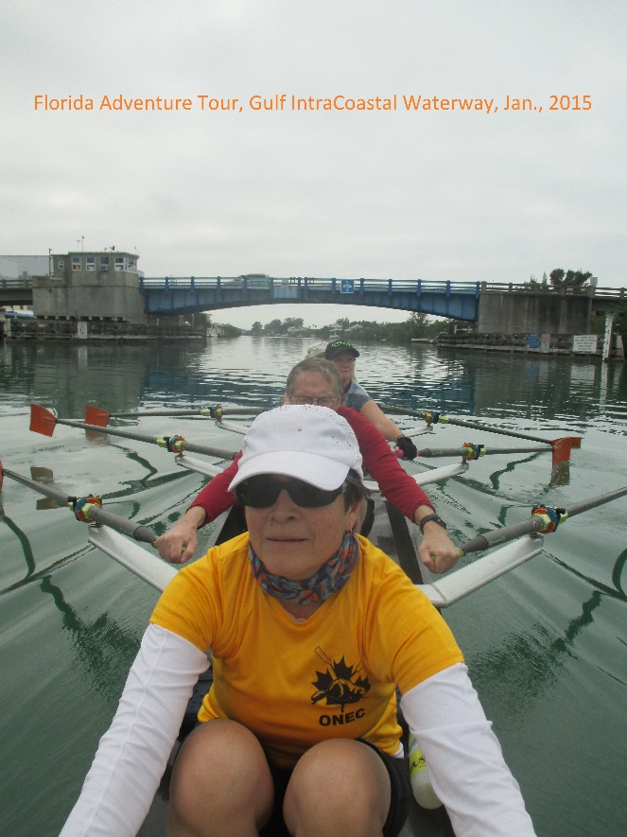 | 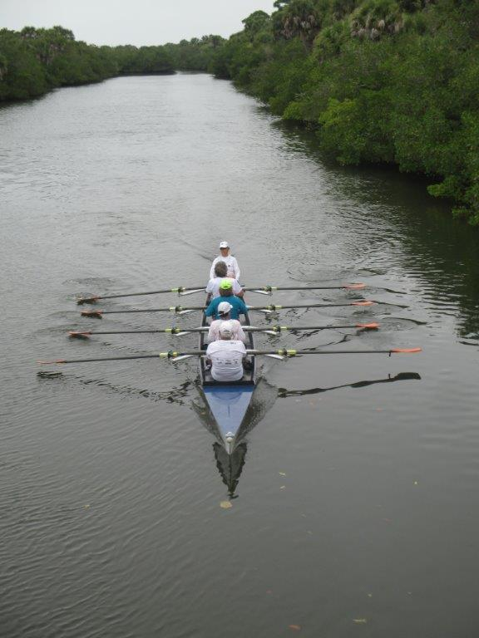

Other Opportunities for Sculling in Florida’s Gulf Intracoastal Waterway in February, 2018

Quad rentals
We also rent out a coxed touring quad, located on the Intracoastal Waterway. to member Clubs of the Ontario Adventure Rowing Association (OAR). The price is $CDN 550 for 5-6 days.
Enquire with Richard Vincent at vincric@rogers.com.

Additional tours
Ask about other tours in February, 2018 (Feb. 10 to 17 or Feb. 24 to Mar. 3), if you or your group cannot make February 17 to 24.

Weekend Sculling Camps
There is the possibility of weekend sculling camps in February 2018 given by a renowned coach.
Enquire with Bruce Green at sysblg@gmail.com

