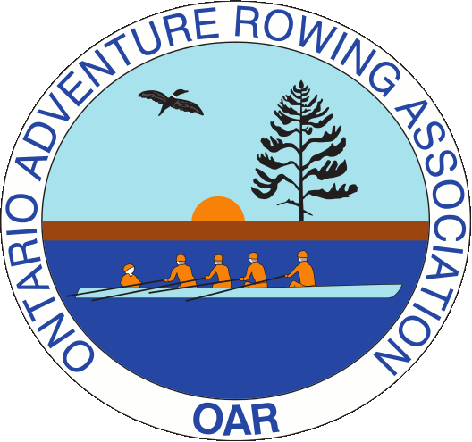
Muskoka Tour 2020

Useful Information

There are group accommodations this year. How does that affect the launch sites and parking?

We are staying at the New Baldwin Inn on Lake Rosseau. The Inn has provided us with an accommodation and meal package that covers accommodation on both Friday and Saturday night, two breakfasts, boxed lunches to take with us each day, and a Saturday evening meal. Car and boat trailer parking are on site – no need to move any vehicle after you arrive.

There is a small beach close to the Inn. We may be able to leave the boats on the beach overnight. If not, we will just carry them up to the Inn and lay them on the lawn.

Where are we rowing?
On Saturday, we are rowing north on Lake Rosseau, through some magnificent glacier sculpted gneiss. On Sunday, we are rowing south to Port Carling. On both days we will return to Windermere. We will not be going through any locks.

Seriously, we’re not going through any locks?

No locks.

Are my feet going to get wet?

Yes, all launches, lunches, and returns are wet.

Where’s lunch?

On Saturday, lunch is at Four Mile Point Park, where we land. There are toilets here.
On Sunday, lunch is at Port Carling in the picnic area near the locks. There are toilets here.
If you have dietary restrictions or ideologies, please let me know as soon as possible, so that I can alert The New Baldwin Inn kitchen.

What should I bring for the row?

Sunscreen, reusable water bottle and a sense of adventure! A fanny-pack life jacket, if you have one and would prefer it. A rain jacket – if you bring it, it won’t rain. If you don’t...Wrenches for rigging and e-rigging.

What is being supplied by the tour organizer?

Boats, oars, life-jackets, water in jugs, maps of the routes, boxed lunches, waivers for signature, a first-aid kit, and a sense of accomplishment.

Questions that aren’t answered here? Fire away: planetwarn@gmail.com

